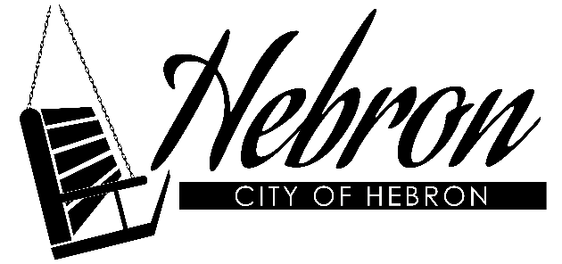
2026 Mowing Bids

NOTE:
*BIDS DUE TO CITY prior to 7:00 p.m. Council Meeting on February 2nd
*All mowing bids must include mowing and trimming in the bid.
*Prior approval for additional mowing must be approved by Doug Modlin
* Park Board members may request additional mowing for special events.
*A BID sheet will be completed for EACH Property.
*1 Year Contract
PROPERTY: Willard Park
MOWING EXPECTATIONS: Mow Highlighted area located on the Map, Trim around Sidewalks, Trees, and Structures as Needed, Blow/Sweep off Sidewalks after Mowing
MOWING DATES:
April 1st – June 30th – Once Every 7 – 10 days as Needed
July 1st - Sept. 30th - Once Every Two Weeks (unless prior approval from Lance is granted for more)
*City may request mowing to be done past the required date if grass is still growing.
CONTRACTS: Contracts will be mailed out immediately to awarded mowing bids to be signed and returned to the city office 10 days after receipt.
INVOICES: After bids are awarded-invoice sheets will be mailed out for mowers to complete each month. Invoice sheets must be submitted to the city office by the First Monday of the month.

NAME / BUSINESS ______________________________________________
ADDRESS ______________________________ CITY ________________ STATE _______
PHONE ______________________________ CELL PHONE __________________________

BID PER MOWING (Mowing and Trimming) for Property listed above: _________________
- $1,000,000.00 Liability Insurance Must be Submitted with Contract
_________________________________
SIGNATURE

