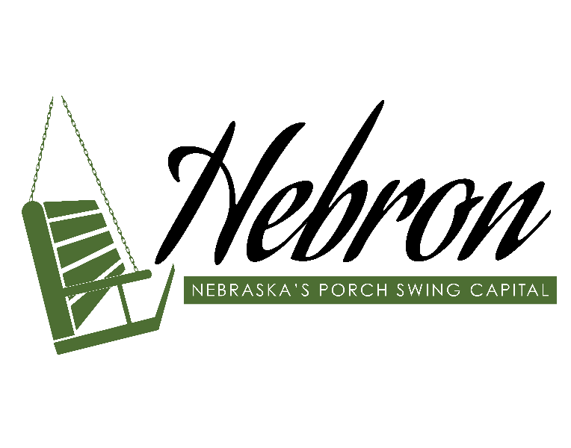

Hebron Downtown Revitalization
2022 Program Guidelines


Submit Application to: Hebron Downtown Revitalization Program 216 Lincoln Ave. Hebron, NE 68370

TABLE OF CONTENTS

PROGRAM OVERVIEW…………………………………………………3
APPLICATION……………………………………………………………5
REVIEW………………………………………………………………….10
IMPLEMENTATION…………………………………………………….12
COMPLETION…………………………………………………...............15
ADDITIONAL GUIDELINES…………………………………………...16
ABBREVIATIONS AND DEFINITIONS OF TERMS USED………….17
COMMERCIAL BUILDING DESIGN FEATURES & DEFINITIONS..18

PROGRAM OVERVIEW
Statement of Purpose
The purpose of Hebron’s Downtown Revitalization (DTR) Program is to assist in the creation of a cohesive, cost-effective and vibrant downtown district and to encourage pride in downtown Hebron. Applicable projects will restore, improve or preserve historic, architectural and aesthetic features of buildings within Downtown Hebron.
Program Goals
*Improve the economic potential of individual buildings and the entire downtown area.
*Strengthen property values and reduce or eliminate vacancies in the core downtown.
*Enhance the environmental and historical quality of the downtown business area through preservation and rehabilitation of original or historic commercial buildings.
*Bring substandard building conditions into compliance with basic health, safety, and building codes and enhance the visual appeal of downtown businesses through façade improvements.
*Facilitate compliance with American with Disabilities Act (ADA) accessibility requirements.
Funding Sources
The DTR Program receives funds from the Community Development Block Grant (CDBG) from the Nebraska Department of Economic Development (NDED) and from the Hebron Community Fund and the City of Hebron.
All participants in the DTR program will need to provide private funds as local match. Information about matching funds can be found in these guidelines. Additional funding from the LB840 Block Grant Assistance Program is available via a separate application. Details about the LB840 Block Grant Assistance Program are online: https://www.hebronnebraska.us.
Participants are encouraged to consult with the City of Hebron and Nebraska’s State Historic Preservation Office (SHPO) to determine eligibility for financing tools and tax incentives. SHPO is available by calling 1-800-833-6747 or via email at hpnshs@nebraskahistory.org.
Program Administration
This program is jointly administered by the City of Hebron and Southeast Nebraska Development District (SENDD). All applications must be submitted to: City of Hebron, Hebron Downtown Revitalization Program, 216 Lincoln Ave, Hebron, NE 68370 before the application deadline to be determined by the Downtown Revitalization Committee.

3
COMPLETION
IMPLEMENTATION
REVIEW
APPLICATION

Outline of Workflow
- Application
Applicants should review the program guidelines and materials checklist before submitting during the open application period. SENDD and City Staff will ensure application is complete.

- Review
Applications will be reviewed by the Downtown Revitalization Committee and referred to City Council for award. Applicants will receive notification of selection or non-selection.

- Implementation
Upon award, an authorized notice to proceed is required prior to beginning project activities.

- Completion
Upon completion of project activities, an authorized notice of work completion must be obtained prior to submitting invoices for reimbursement.

Compliance with all program guidelines is necessary for reimbursement of funds.

4
APPLICATION
The application form and required applications materials are provided in the Appendix. A copy of the program guidelines and application are available at the City Office and online at https://www.hebronnebraska.us.
Submit applications to: Hebron Downtown Revitalization Program, 216 Lincoln Ave., Hebron, NE 68370. Complete applications will be submitted to the Downtown revitalization Committee for review. Please review all guidelines carefully before submitting your application.
Application Cycles
The program application cycles will be determined by the Downtown Revitalization Committee and will be announced if city receives notification of award.
Eligibility
The DTR program is available to property owners, business owners, and tenants within the area defined by the 2003 Blight Study as Redevelopment Area 2. A map of the eligible project area is included in these guidelines. To be eligible for award, applicants must own or lease a property located with the geographic boundaries of this eligible project area.
Applicants
Business entity applicants (e.g., corporations, limited liability companies, and partnerships must be authorized to transact business in the State of Nebraska and must have an active, valid registration with the Nebraska Secretary of State. Applicants that are debarred, suspended, proposed for debarment, placed in ineligibility status, or voluntarily excluded from covered transactions by a federal agency are ineligible to receive an award. Attestation of U.S. Citizenship will be required if applicant is an individual or a sole proprietor.
Properties
Eligible properties are commercial or mixed-use buildings or structures located within the Eligible Project Area. The principal use of the property must be a commercial use, which means at least fifty percent (50%) of the total square footage of the building or structure is intended or used for commercial purposes. Buildings or structures that are not structurally sound are not eligible properties.
Eligible Activities/Improvements Program funds may only be used for the following eligible activities:
*The preparation of a necessary structural engineering review;
*Architectural plans and engineering specifications; and,
* The cost of building materials and construction labor for façade improvements or to fix code violations.
5
Examples of façade improvements:
*Restoration, replacement, or reconstruction of signage, awnings, window, or doors.
*Brick, stucco, masonry and exterior surface repair or restoration for historic preservation.
*Repair, restore, or replace historic features such as pediments, cornices, lintels, bulkheads
*Building mounted façade lighting
*Exterior wall repairs, restoration installation of decorative details & other design features
*Roofs may be considered with a minimum of 2-3 other blighted elements and eligible façade elements. All elements must be documented and photographed. Limited to work performed on the inside of the wall flashing and may not exceed 40% of reimbursable cost of façade project. Roof repairs alone are considered maintenance and are not eligible for grant funds.
*Painting is eligible for exterior façade improvements in combination with above activities or permanent signage for restoration and historic preservation that are fixed to the structure. NOTE: painting by itself is considered maintenance and program funds may not be used for maintenance activities.
Fixing Code Violations
- Program funds may be used for costs associated with fixing municipal code violations.
- In order to be an eligible activity, the applicant must submit documentation from the City Engineer or hired Building Inspector that documents specific code violations and required repairs.
Any activities that may be considered maintenance are ineligible activities under federal regulations. All repairs, improvements, or other work must conform to state and local building codes and design standard or the activities or improvements will be declared ineligible.
INELIGIBLE Activities/Improvements
*Residential
*Interior Improvements that do not address code violations
*Roof and gutter replacement maintenance or repairs
*Some code issues will not be covered (this will be on a case by case basis)
*Painting as a sole activity
*Sidewalks
NOTE: Any activities that may be considered maintenance are ineligible activities under federal regulations. All repairs, improvements, or other work must conform to state and local building codes and design standards, or the activities or improvements will be declared ineligible.
6
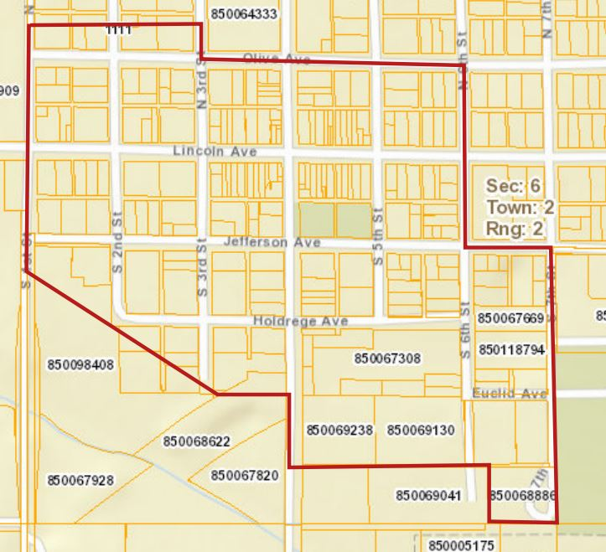
Eligible Project Area Map

The Downtown Revitalization Project Area encompasses the “original Town” of Hebron. This area includes the central business district along Lincoln Avenue and some of the surrounding residential areas. This area was identified in a 2003 blight and Substandard Study as Redevelopment Area 2. The blight and substandard designation for Redevelopment Area 2 was re-adopted in 2019.

7
Assistance Details
Maximum Grant Award
The maximum amount of CDBG funds that may be awarded to the City of Hebron during this program cycle is $400,000 for all program activities. Applicants may request any award amount up to the maximum. The DTR Committee has not established a maximum amount per property at this time, however the Council reserves the right to grant an award that is less than the amount requested.

If a request exceeds $150,000 in CDBG funds per property (or current small purchase threshold, per 2 CFR 200.88) then business owner(s) must include a policy for compliance with 24 CFR 570.489(j) and 24 CFR 570.503(b)(7) for five years after the CDBG Contract date of completion. This involves meeting the national objective of slum/blight elimination and complying with change of use rules.
Matching Funds
CDBG funds and funding provided from the Hebron Community Fund may be used to reimburse up to 75% of total project costs, up to the maximum amount of funds awarded.
The LB840 Block Grant Assistance Program
The LB840 Block Grant Assistance Program can provide funds to match the business owner contribution at 1:1 ratio. LB840 Funds must be applied for separately. Details about the LB840 Block Grant Assistance Program can be obtained from the City Offices or found online: https://www.hebronnebraska.us.
Example Project Cost Breakdowns
*A proposed project that will cost approximately $12,000 would be eligible for an award of up to $9,000 in CDBG funds and will require at least $3,000 in matching funds. This could include $1,500 from the local business owner, and $1,500 from the LB840 Block Grant Assistance Program.
*An award of $50,000 would require at least $12,500 in matching funds. This could include $6,250 in funds from the business owner, and $6,250 in funds from the LB840 Block Grant Assistance Program.

8
Application Materials
Application Form
The application form and required applications materials are provided in the Appendix. A copy of the program guidelines and application are available at the City Offices and online at https://www.hebronnebraska.us.

Submit applications to: Hebron Downtown Revitalization Program, 216 Lincoln Ave., Hebron, NE 68370. Complete applications will be submitted to the Downtown Revitalization Committee for review. Please review all guidelines carefully before submitting your application.
Additional Materials
All application must include the project-specific documents listed on the application Form and must provide the following additional materials (see Appendix for the Application Checklist):
- Property ownership documentation or a copy of the applicant’s current lease and a letter from the property owner authorizing the application and the work to be performed.
- A completed Proposed Property Improvement Plan. Any proposed activities or improvements must be consistent with the City’s Design Standards and Guidelines. The Property Improvement Plan shall include a construction drawing of the property with descriptions of proposed activities or improvements and showing the approximate locations. Please include a rough timeline of proposed activities.

- Color photographs of existing façade on all exposed sides.

- Color photographs of specific areas where requested improvements would occur.

- Cost estimates from multiple (2-3) independent contractors to verify the proposed costs are within reasonable parameters.

- Applicants are responsible for preparing the project specifications, work-writeups, or other documents necessary to obtain cost estimates on the proposed project activities.

- Unless specifically noted in the application request, applicants are fully responsible for any architectural fees, preparation of design specifications, engineering fees, and any other costs associated with developing their application.

- US Citizenship Attestation Form, if required.
*Contact the City for assistance in obtaining color photos or cost estimates.
9
REVIEW
Incomplete applications will not be eligible for consideration. Applicants who submit incomplete applications before the close of the application cycle may be contacted about the deficiencies in their applications. Applications or parts of applications received after the cycle deadline will not be accepted.
The City of Hebron will consult Southeast Nebraska Development District (SENDD), and/or the City Attorney to ensure prospective projects comply with federal, state and local program

guidelines. The City will verify property ownership/tenancy and property taxes, special assessments, or liens on the property, potential conflicts of interest, and building code/zoning compliance. Any additional materials requested from the business owner in order to determine eligibility and compliance must be provided prior to referring the project to the Hebron City Council for award of funds.
Conflicts of Interest
No employee, officer, or agent of the municipality shall participate in the selection, award, or administration of a contract supported by federal funds if a conflict of interest, real or apparent, would exist. Such a conflict would exist when an employee, officer, or agent; any member of his or her immediate family; his or her partner; or an organization that employs, or is about to employ, any of the above has a financial or other interest in the award. Conflicts of interest may also exist under the Nebraska Political Accountability and Disclosure Act or under federal regulations. Municipal employees, officers, or agents shall neither solicit nor accept gratuities, favors, or anything monetary value from contractors, potential contractors, or parties to subcontracts. City Staff will review applications for any potential conflicts of interest. Conflicts that arise after an award of funds may be cause for the immediate revocation of the award and may result in penalties or sanctions under federal or state laws and regulations.
Code Compliance Review (Code Enforcement)
City Staff will review applications to determine if the proposed activities or improvements comply with currently adopted municipal building codes, Sign Regulations, or other applicable ordinances.
Structural Engineering Review
Buildings or structures that are not structurally sound are not eligible properties. The City may require a structural engineering review to determine if a building or structure is structurally sound. If a review is required, the applicant may use the services of the City’s Engineer or may use another qualified firm. All costs of the review shall be paid by the applicant; however, if the application is selected for an award, any reasonable costs associated with the review and report will be included in the total project costs.
10
Council Committee Review
The Hebron Downtown Revitalization (DTR) Committee will review all complete applications to determine how well the proposed activities or improvements comply with the Program Design Standards and will score applications based on the priority ranking system and selection criteria. This Committee will then make recommendations for award to the City Council.
Program Design Standards
Where practicable, building and structure facades should be restored to the original period design for the building or structure:
- All unique historical features must be retained.
- If practicable, deteriorated architectural features should be repaired rather than replaced. If replacement is necessary, new materials should match as closely as possible in design, color, texture, and other visual qualities to the original.
- All repairs, replacements and improvements shall be designed, constructed, and maintained to complement and accent the original qualities, character, and architectural features of the building.
- The use of incompatible materials for reconstruction of facades is prohibited.
- Non-conforming or incompatible exterior materials, such as stucco, vinyl, and aluminum, should be removed whenever possible.
- All accessories, signs, and awnings shall harmonize with the overall character of the building and area. All color schemes shall accent the building, as well as harmonize with the historic character of adjacent buildings.
- Signs and awnings must comply with the City’s Sign Regulations and should accentuate the period architecture.
- Replacement windows, doors, and glass should be similar in size, color, and reflectivity to original.
Priority Ranking and Selection Criteria
Priority shall be given to applications that propose activities or improvements that:
- Restore the building or structure façade in compliance with SHPO requirements.
- Bring the façade into conformance with the Program Design Standards; and,
- Fit the City Council’s revitalization priorities and downtown district design vision and goals.
City Council Award
The City Council will consider the DTR Committee’s recommendations at its first regularly scheduled meeting after the close of the application cycle and will make the decision to award or not award any project independently from the recommendation of the Committee. Nothing herein shall be interpreted to require the City to grant an award to any project. The City reserved the right to accept or reject any or all of the applications.
11
Notification of Selection or Non-selection
Within thirty days of the decision of the city Council, the City will notify applicants of award selection or non-selection by an official, written notice signed and dated by the Mayor. If the application was not selected for an award the notification will inform the applicant of the reason for non-selection.
IMPLEMENTATION
Grant Award Contract
The City and award Recipients will enter into a grant award contract to ensure that the Recipient agrees to the conditions of the Program and understands its rights and obligations, including those obligations required by the Nebraska Department of Economic Development.
The Recipient will be responsible for generating their own contracts, agreements, or other documents with any contractors or subcontractors hired by them. These agreements must be executed, and a copy provided to the City, prior to the disbursement of any grant funds. All subcontractors; under no circumstances will the City enter into any contracts or other agreements with contractors or subcontractors.
Funding Terms
Funding will be awarded on a reimbursement basis upon the authorized completion of approved project activities. Local lenders are encouraged to provide short-term financial assistance to business owners.
All awards will be structured as conditional grants, the repayment of which will be required if the conditions specified in the grant award contract are not met. These conditions generally require the Recipient to comply with all federal, state, and local laws, regulations, and program guidelines.
All rehabilitation work approved by the City under the Program must be completed by the deadline established by the Downtown Revitalization Committee.
SHPO and Historic Preservation Review
The Property Improvement Plan provided with the application materials will be submitted to SHPO for review before a Notice to Proceed is issued. For properties identified by SHPO as having historic relevance, the Property Improvement Plan shall be adjusted to incorporate any reasonable recommendation of SHPO into the planned project activities or improvements.
Notice to Proceed
The Recipient or its contractors must submit a copy of any required building, sign or other city permits before a Notice to Proceed will be issued. The City has waived permit fees for work conducted in association with this Program. Once all reviews are completed, all required program documents are executed, and all city permits are obtained, the City will notify
12
Recipients that their projects may begin by an official, written notice signed and dated by the Mayor. No project shall begin work prior to the date stated on the Notice to Proceed. Work initiated prior to authorization of notice to proceed will not be reimbursed.
Procurement Process
Approved applicants should solicit cost estimates (bids) from multiple (2-3) sources for the proposed project in order to verify the costs are within reasonable parameters. The Hebron DTR Committee may waive this requirement in special circumstances.
Recipient may select one or more of the contractors that provided cost estimates to perform the proposed work or may rebid all or any portion of the work. Regardless of the contractor selected, Recipients will only receive reimbursement for eligible expenses up to the maximum amount awarded and will be responsible for all costs that exceed the proposed total project cost.
All contractors and subcontractors performing work under this Program must be authorized to transact business in the State of Nebraska, must have an active, valid registration with the Nebraska Secretary of State, and must meet all applicable requirements of the Nebraska Contractor Registration Act. Contractors or subcontractors performing work as individuals or sole proprietors must be lawfully present in the United States and must complete the United States Citizenship Attestation Form.
No contractor or subcontractor that has been debarred, suspended, proposed for debarment, placed in ineligible status, or voluntarily excluded from covered transactions by a federal agency or any applicable government debarment and suspension regulations may perform work as part of this Program.
Pre-construction Meeting
The SENDD administrator will meet with approved business owners and contractor(s) to review federal compliance guidelines and complete compliance documentation at a pre-construction meeting prior to beginning any work activities.
Construction Process
All activities or improvements must comply with all applicable building codes, zoning ordinances, programs design standards, and historic property requirements. Contractors are required to have inspections done by a Building Inspector whenever required by the City.
All grant funds will be disbursed as reimbursement for expenses incurred. Contractors must submit invoices to Recipients for payment and may choose to submit a copy to the City at the same time. Recipients must submit a copy of the invoice as well as verification of payment.
When it is determined that the quality of work is satisfactory to the Recipients and meets all city requirements, the City will reimburse the Recipient for 75% of the amount paid for eligible expenses up to the maximum amount of the grant award.

13
Compliance Review
Before and after a project is awarded, the DTR Committee will consult with SENDD to ensure the project activities follow all federal, state and local program guidelines.
Compliance with SAM/E-Verify Requirements
The System for Award Management (SAM) is an official website of the U.S. government and E-Verify is a web-based system that allows enrolled employers to confirm the eligibility of their employees to work in the United States.
E-Verify employers verify the identity and employment eligibility of newly hired employees by electronically matching information provided by employees on the Form I-9, Employment Eligibility Verification, against records available to Social Security Administration (SSA) and the Department of Homeland Security (DHS).
All contractors and subcontractors must meet e-verification requirements and may not be subject to exclusion in SAM. It will be the responsibility of the property owner or grant fund recipient to ensure contractors and subcontractors are aware of these requirements.
Compliance with Davis-Bacon Requirements
Davis Bacon Wage Determinations apply to all contractors involved in construction projects of $2,000 or more (aggregate project costs, not individual contracts). In order to fulfill Davis Bacon Compliance-contractors will be instructed on how to document their wages, payroll, interviews, posters, etc.
A Wage Determination is the listing of wage rates and fringe benefit rates for classifications of laborers and mechanics which the Wage and Division of the U.S. Department of Labor has determined to be prevailing in a given area for a particular type of construction (e.g., building, heavy, highway, or residential). In accordance with the provisions of 29CRF Part 1 and Part 5, the wage rates and fringe benefits in the applicable Davis-Bacon wage determination shall be the minimum paid by contractors and subcontractors to laborers and mechanics.
Wage Interview
During implementation the contractor must notify SENDD when ready to start construction and must submit weekly payrolls and coordinate with the grant administrator to complete regular payroll interviews with subcontract/subcontractor employees while on site during construction.
Payroll Requirements
For every week that a contractor or its employees are on the job, the contractor is required to submit Davis Bacon Payroll Certifications. These shall be submitted immediately after the applicable week ending date. No requests for reimbursement will be processed until all payroll forms have been received by the City or SENDD.

14
Compliance with Other Federal Laws Regulations
This program and any project activities undertaken as part of this Program will comply with all applicable federal laws and regulations, including, but not limited to, the Housing and Community Development Act of 1974, 24 CFR Part 570, the Davis-Bacon Act, the Copeland “Anti-Kickback” act, Lead-Based Paint Poisoning Prevention act, and the Civil Rights Act of 1964.
Compliance with Sale and Local Laws and Regulations
This Program and any project activities undertaken as part of this Program will comply with all applicable state local laws and regulations, including, but not limited to, the Nebraska Civil Rights Act of 1969, the Nebraska Fair Employment Practices Act, Nebraska’s Uniform Energy Efficiency Standards, and all regulations and program guidelines adopted by the Nebraska Department of Economic Development.
COMPLETION
Final Inspection
Final Inspection will be completed by the City prior to project closeout to ensure the project was completed in compliance with the grant agreement and all applicable federal, state, and local laws, regulations, and guidelines.
Notification of Project Completion
Upon a successful final inspection, the City will review the project file to ensure all program requirements have been met. If so, the City will issue a notification of project completion and closeout by an official, written notice signed and dated by the Mayor.
Financial Management and Reimbursement
The business owner is responsible for negotiating payment schedule(s) with their selected contractors. The use of a preferred local lender is encouraged to provide for payments to the contractor made prior to completion of the project. Once the project is completed, the City will pay the contractor, or reimburse the business owner, as outlined below.
At the completion of the project, and once an authorized notification of project completion has been obtained, the applicant will submit all invoices to the City of Hebron for reimbursement. When requesting reimbursement, applicant shall provide the City with a copy of the cancelled check to the contractor to document the payment.
The City will reimburse owner or lender for invoiced amounts up to 75% of total project costs. These will be reimbursed at a rate of 71.4% CDBG funds and 3.6% from the Hebron Community Fund. Applicants will be responsible for the remaining 25% match from their own funds. Business owner contributions may be matched 1:1 with LB840 assistance funds through a separate application process.
15
ADDITIONAL GUIDELINES
Sale or Transfer of Property
Improvements must remain intact for a minimum period of five (5) years from the date of completion. Changes to funded improvements prior to five (5) years may trigger repayment requirements to LB840 program requirements and/or forfeit of CDBG funds.
Conflicts Between Agreements/Regulations/Guidelines
In the event of any conflicts between any provisions of these Program Guidelines, the Nebraska Department of Economic Development’s CDBG Administration Manual, any grant agreements entered into between the City and the Nebraska Department of Economic Development or between the City and the Recipient, and any federal, state, or local laws or regulations, the most restrictive or specific provision shall apply.
Grievance Procedures
All grievances or complaints regarding an award or non-award of funds must be submitted in writing to City. A written response/determination will be provided to the aggrieved party within fifteen days after receipt of the grievance/complaint. If unsatisfied with the response/determination, the aggrieved party may appeal the decision in writing to the City Council for their consideration. The request for appeal must be received by the City within 15 calendar days of the initial decision. The City Council will set a hearing on the appeal within thirty days after receipt of the request for appeal. Final written decision of the City Council will be provided to the aggrieved party within forty-five days after the hearing.
In the even of a dispute between the Recipient and a contractor or subcontractor, an independent mediator, agreed on by both parties, shall be selected. The mediator’s decision on the issue will be accepted as final by both parties.
Environmental Review
All properties will have a Tier II Environmental Review conducted relative to the National Environmental Policy Act of 1969 (NEPA) and its related laws. NEPA was established to ensure environmental protection for government funded projects.
This review shall, at a minimum, include a review of onsite and nearby potential toxic substance contamination, nearby floodplain hazard areas, or the potential for adverse environmental impacts that disproportionately impact any minority of low-income populations within the community, and the impacts of the project activities on the historic nature of the property or adjacent structures.
Process for Amending Program Guidelines
These Program Guidelines can be amended only after review and approval by the Nebraska Department of Economic Development and formal action by the City Council.
16
ABBREVIATIONS AND DEFINITIONS OF TERMS USED
CDBG Community Development Block Grant-Federal program that provides funding for community and economic development projects to encourage additional federal, state, and private resources. Communities receiving CDBG funds use those grants to provide safe and sanitary housing, a suitable living environment, and expanded economic opportunities. The Nebraska Department of Economic Development (DED) administers the CDBG program for most of the state. Due to population size, some cities in Nebraska are the administrators of the Department of Housing and Urban Development (HUD) on an annual basis. Communities can apply to use those funds for the planning and construction of projects that:
- Benefit low and moderate-income persons.
- Prevent or eliminate slum or blight conditions.
- Solve catastrophic health and safety threats.
NDED Nebraska Department of Economic Development-The State agency responsible for economic development, created by the Nebraska State Legislature in 1967. The department’s emphasis is growing and diversifying the state’s economic base by fostering new investment and commercial spending throughout the state.
Façade shall mean the exterior wall of a building exposed to public view from the building’s exterior. This will typically include a visual impact with items such as awnings, windows, and signage.
LB840 The Local Option Municipal Economic Development Act (LB840, 1991) authorizes incorporated cities and villages to collect an appropriate local tax dollars-including sales and/or property tax, if approved by the local voters-for economic development purposes.
SENDD Southeast Nebraska Development District is a voluntary association of counties and municipalities formed under the Nebraska Interlocal Cooperation Act to identify common problems, their solutions, and to provide continuing support for efficient and effective government among its members. Website: https://www.sendd.org/
SHPO State Historic Preservation office. Participants are encouraged to consult with the City of Hebron and Nebraska’s State Historic Preservation Office (SHPO) to determine eligibility for financing tools and tax incentives. SHPO is available by calling 1-800-833-6747 or via email at hpnshs@nebraskahistory.org

17
COMMERCIAL BUILDING DESIGN FEATURES AND DEFINITIONS
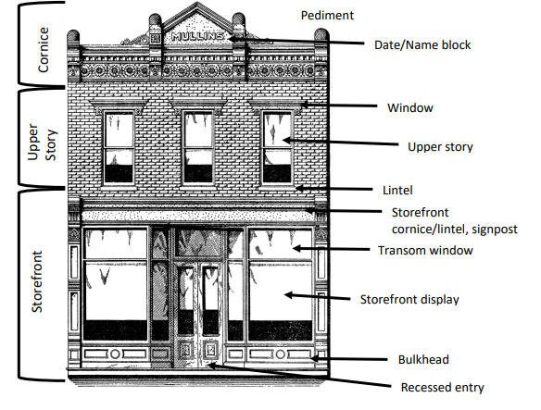

Bulkhead – Located between sidewalk and storefront window, the bulkhead raises the display area for better viewing and provides a base that can withstand pedestrian traffic for the storefront windows. Bulkheads were often constructed of wood. Because bulkheads are vulnerable to weather and damage, many have been replaced with more durable materials like tile, stone and brick.
Cornice – The cornice tops the main facade of a building. This feature is typically made of decorative formed metal or patterns of brick, sometimes terra cotta or stone in larger commercial buildings in urban areas.
Date/Name Block – The date block and sometimes a name block can be found within the design of the cornice or below the cornice on the upper part of the facade. It contains the date the building was built and/or name of the original building owner(s).
Facade – The main or front exterior face(s) of a building.
Lintel – Horizontal piece located at the bottom of a window, door or other opening.
Sign Panel – Located above the storefront, this space for signage was traditionally defined with a brick frame.
18
Storefront Cornice/Lintel – Not as elaborate as the cornice atop the building, it’s used to cap the top of the storefront opening. Also serves as a structural element carrying the weight of the upper facade wall.
Storefront Display Windows – Originally used to bring natural light into the building, they provide an excellent opportunity for product and merchandise displays.
Transom Windows – Window area directly above display windows. Filter light back into narrow traditional commercial buildings, illuminating the interior.
Window Hood/Lintel – Decorative piece located at the top of a window, door or other opening.

19

